**IBM API Connect Instance Creation**

1. Access the Platform Navigator. Login to the RedHat OpenShift Container Platform Console using the url, userid and password.

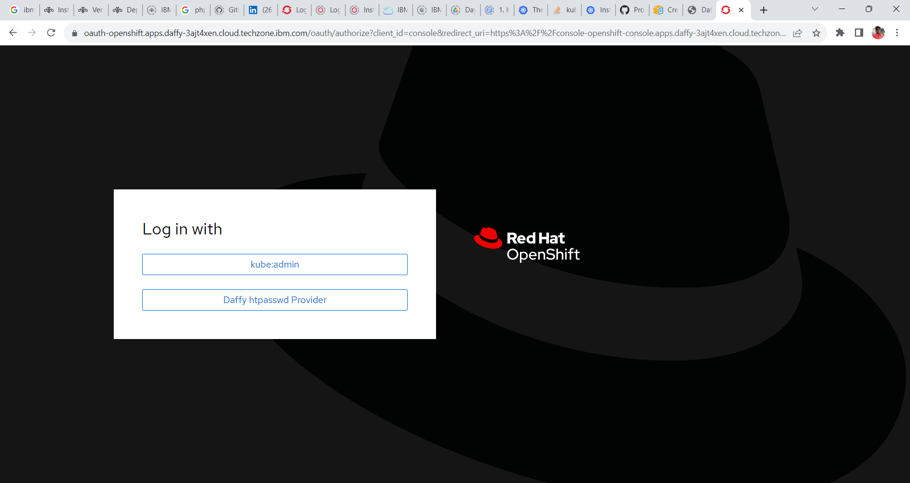

2. Goto **Network -> Routes** and change the project to **CP4I**.

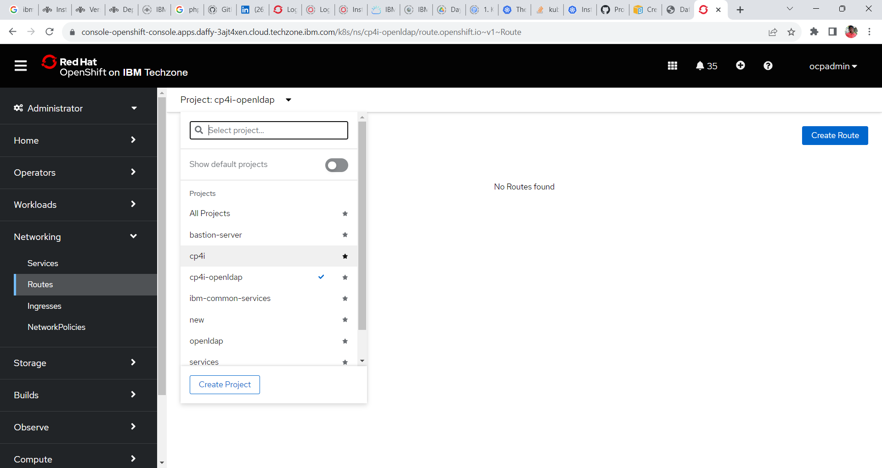

3. Search for Platform-navigator-pn or the name of the platform navigator you have provided and click on the url under location tab to open cp4i Platform UI.

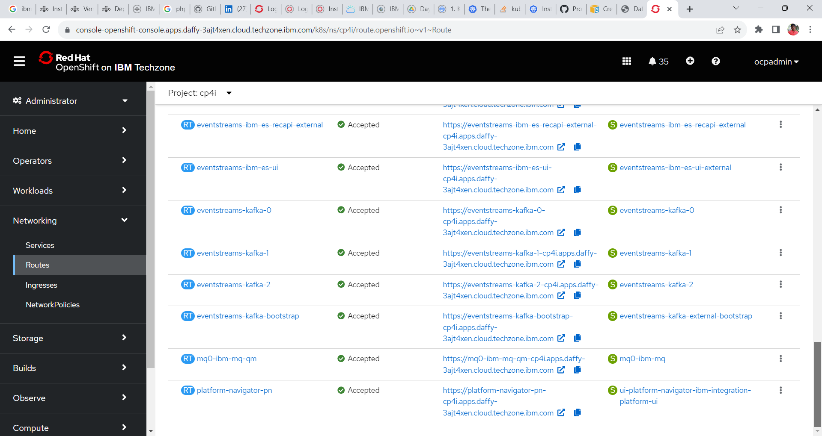

**Log in with = IBM Provided credentials**

**Username = admin**

**Password = < Need to accessed from secrets>**

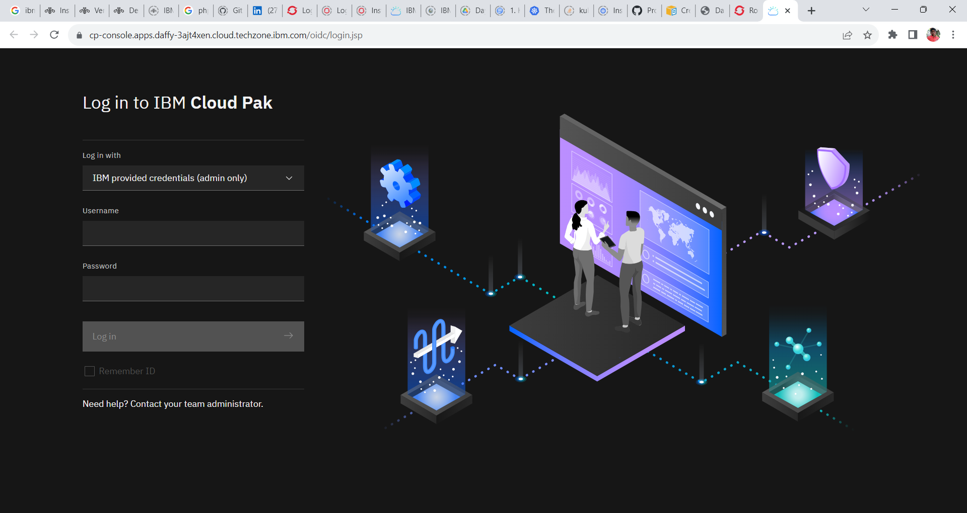

**Access the password for platform navigator**

1. In OpenShift Web Console go to **Workload -> Secrets** and change the project **ibm-common-services**.

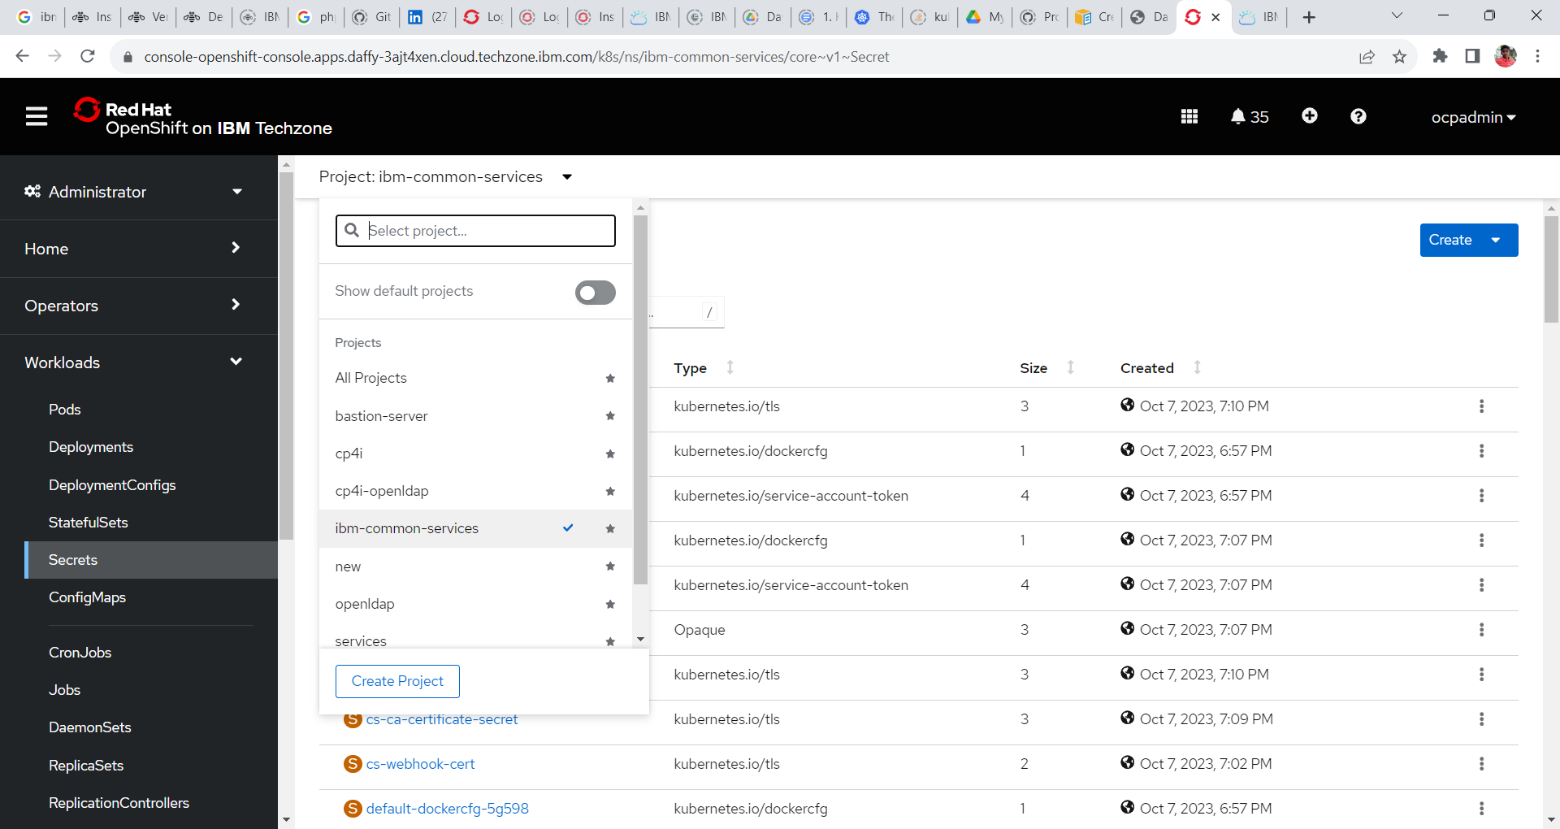

2. Search for the following secrets **platform-auth-idp-credentials** and click to open the same.

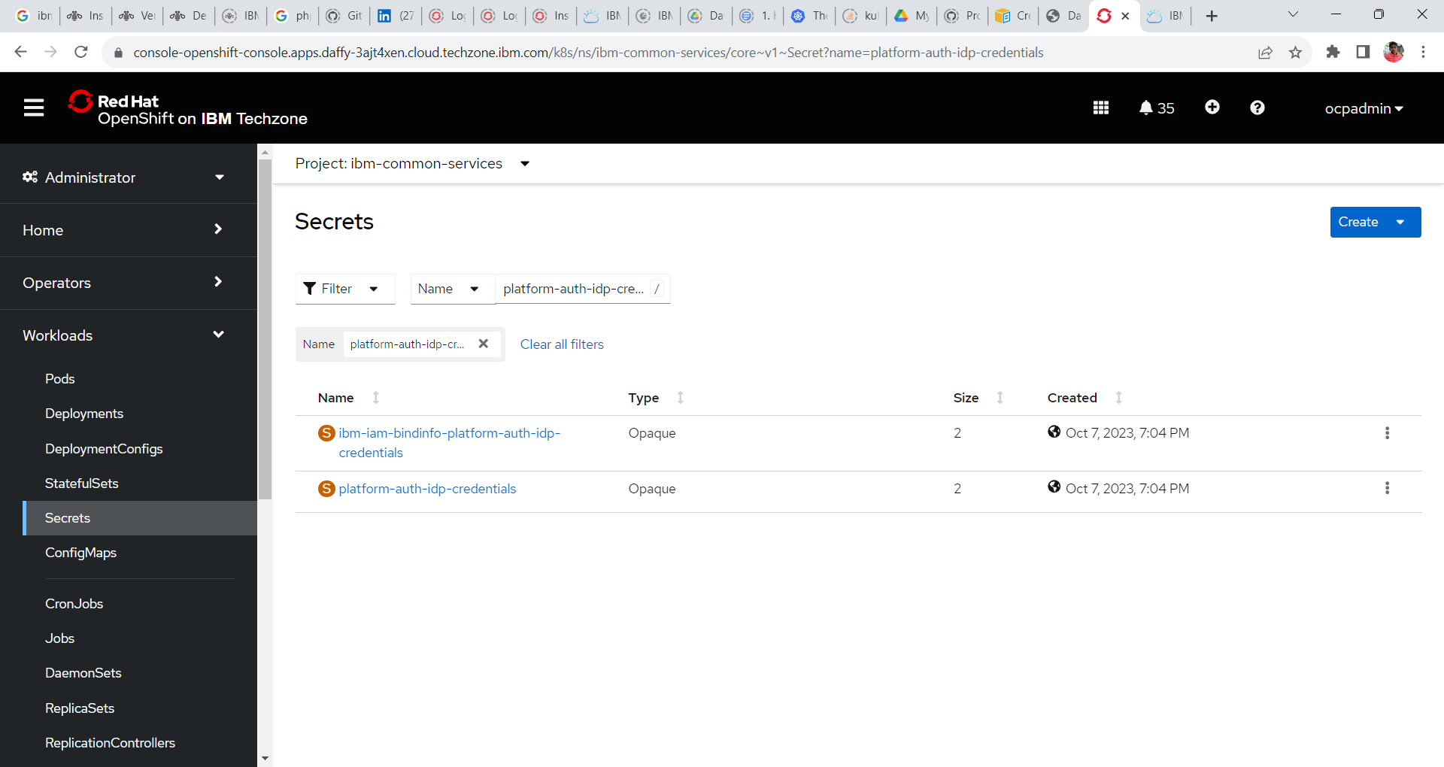

3. Goto the bottom of the screen and click on reveal values to reveal the username and password for the CP4I platform UI.

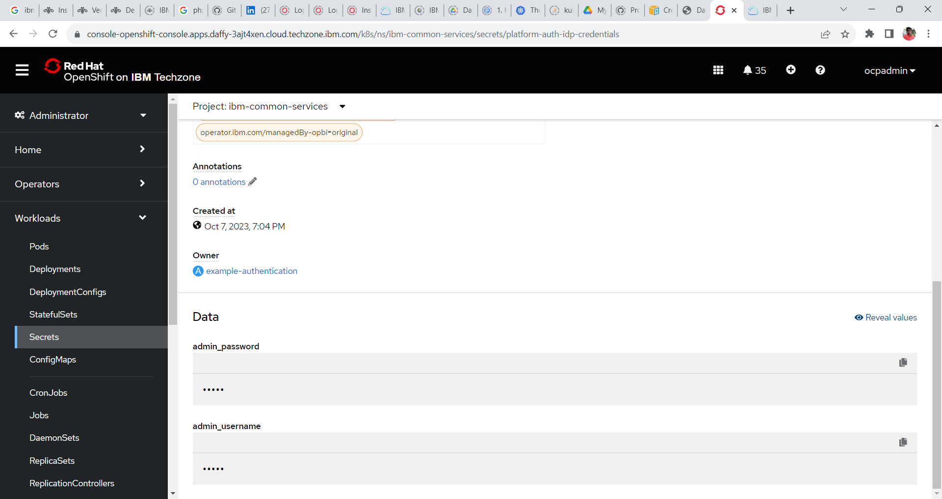

4. Copy the password and login to CP4I platform Navigator.

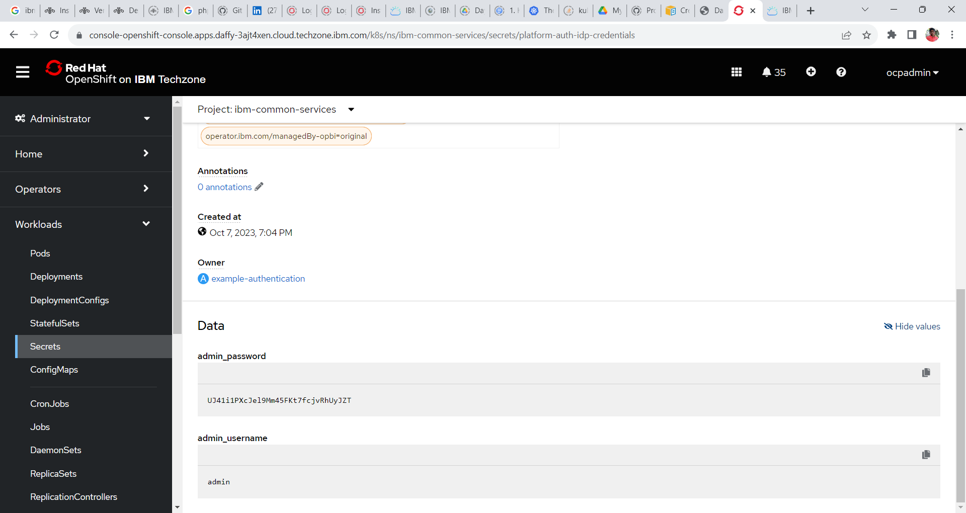

**Click to copy.**

**Platform Navigator**

5. Login to the platform Navigator

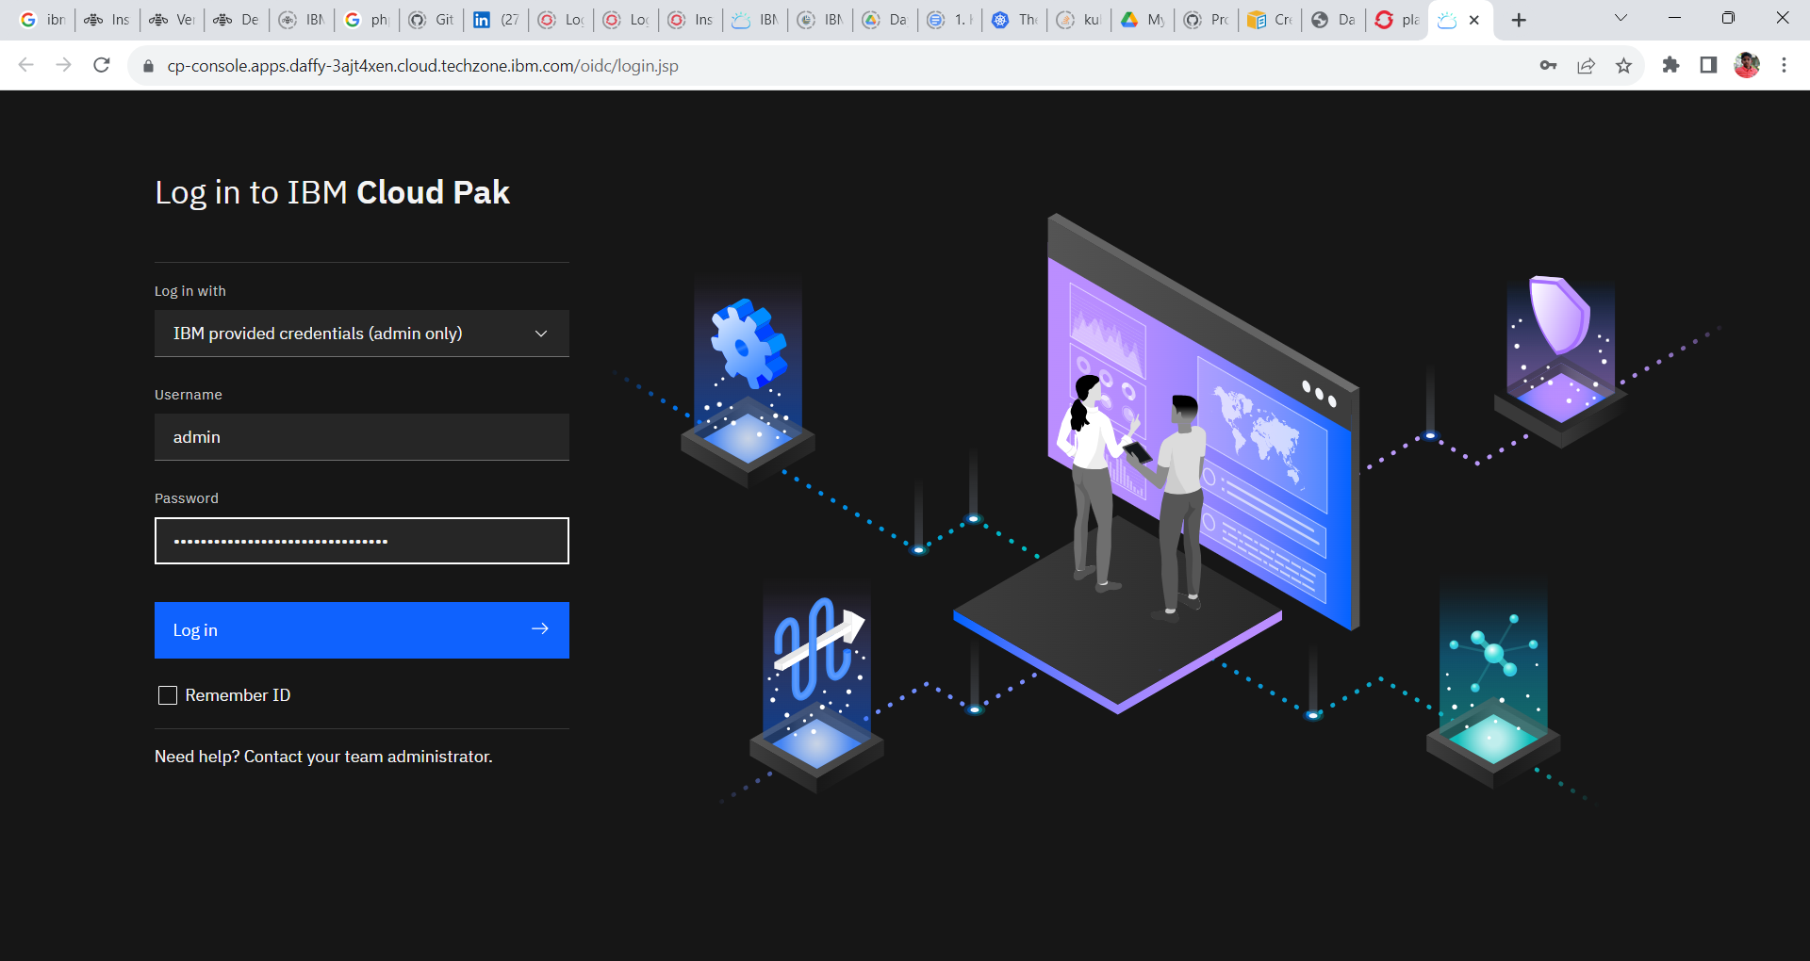

6. Click the integration instances tile or click on menu and click Administration and click on Integration Instances.

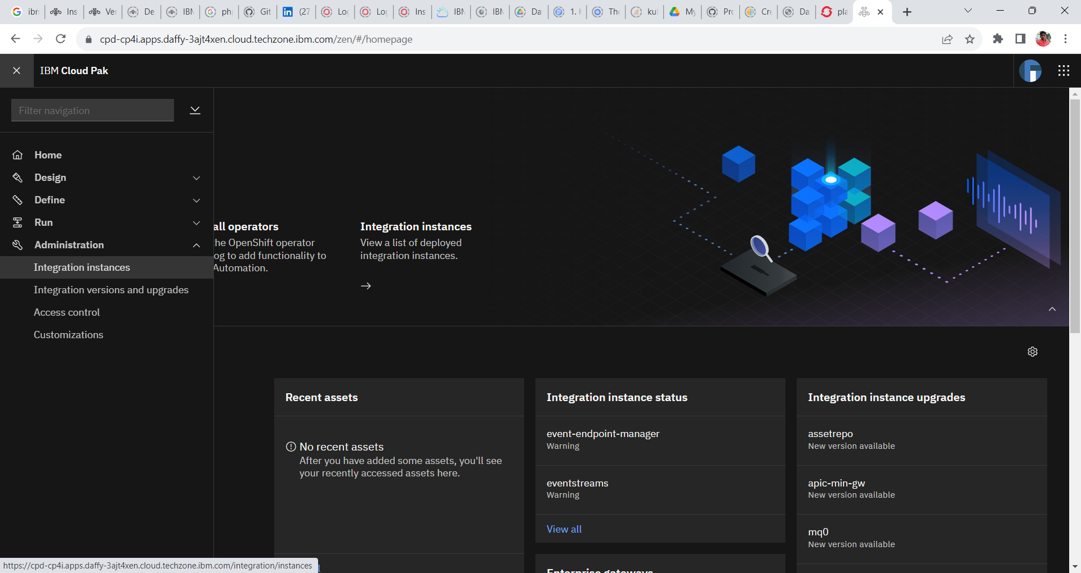

7. To create an instance of IBM API Connect click Create Instance in the window

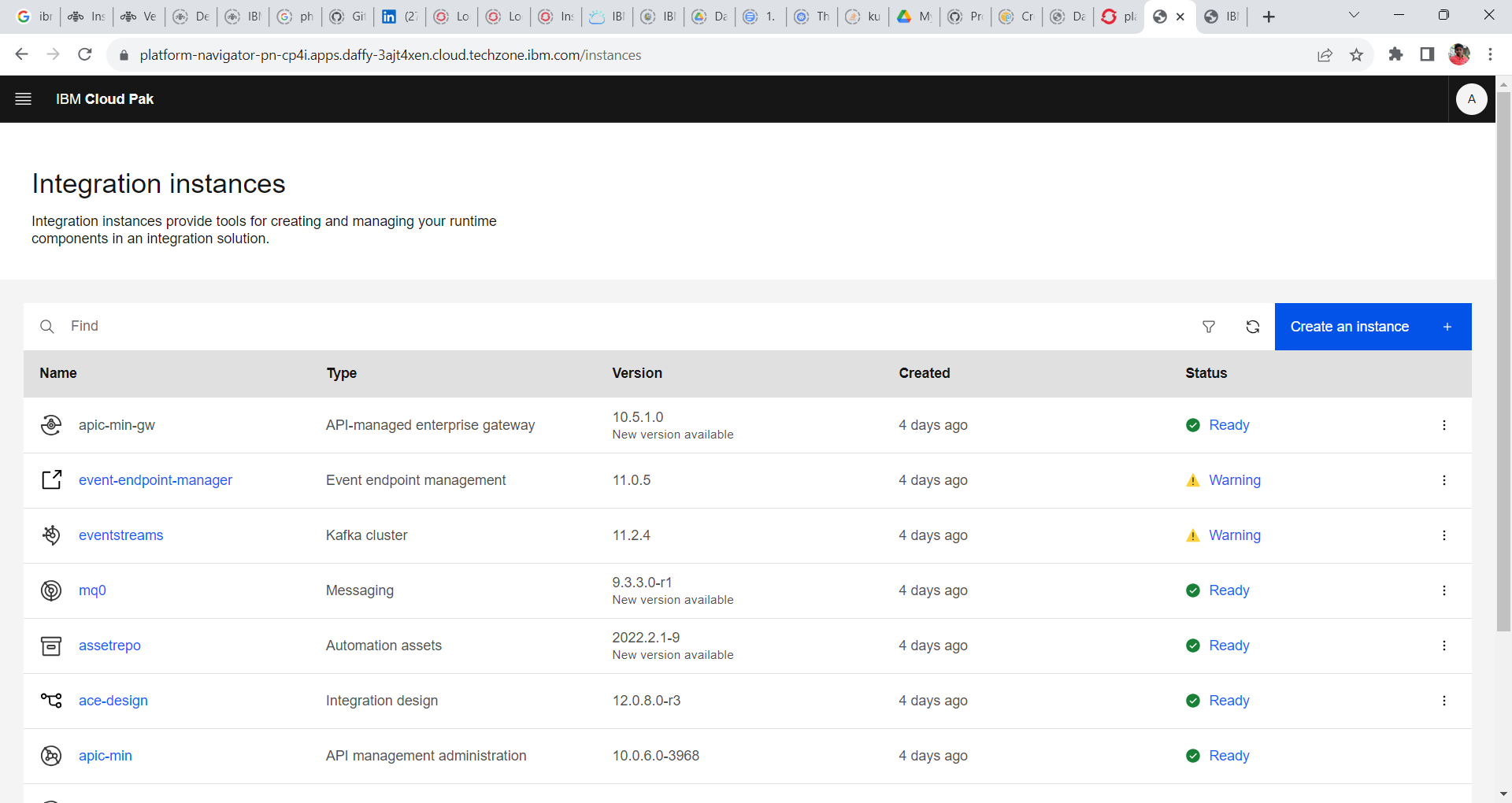

8. Select the API Management tile and click Next. The message tile will be enabled if the IBM MQ operator has successfully installed.

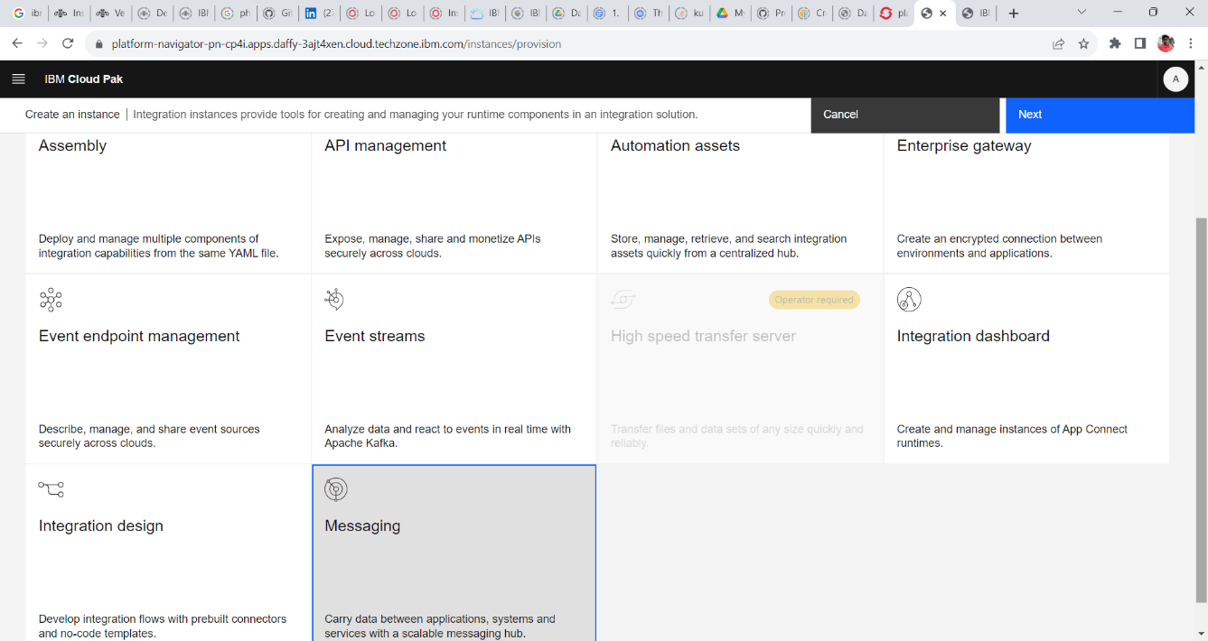

9. Next window displays the Sample tiles through which we can create the IBM API Connect instances. Select the **Small-Single Replica** tile and click next.

10. Provide the following configuration and create the IBM MQ instance.

**Name: small**

**Namespace: cp4i**

**License: Accept the License**

**License Metric: VIRTUAL_PROCESSOR_CORE**

**License Use: nonproduction**

**License ID: <Default>**

**Deployment Profile: n1xc7.m48**

**Product Version: default**

**Storage Class: ocs-storagecluster-ceph-rbd**

Click **Create**.

11. Wait for a few minutes to spin up the IBM MQ Instance.

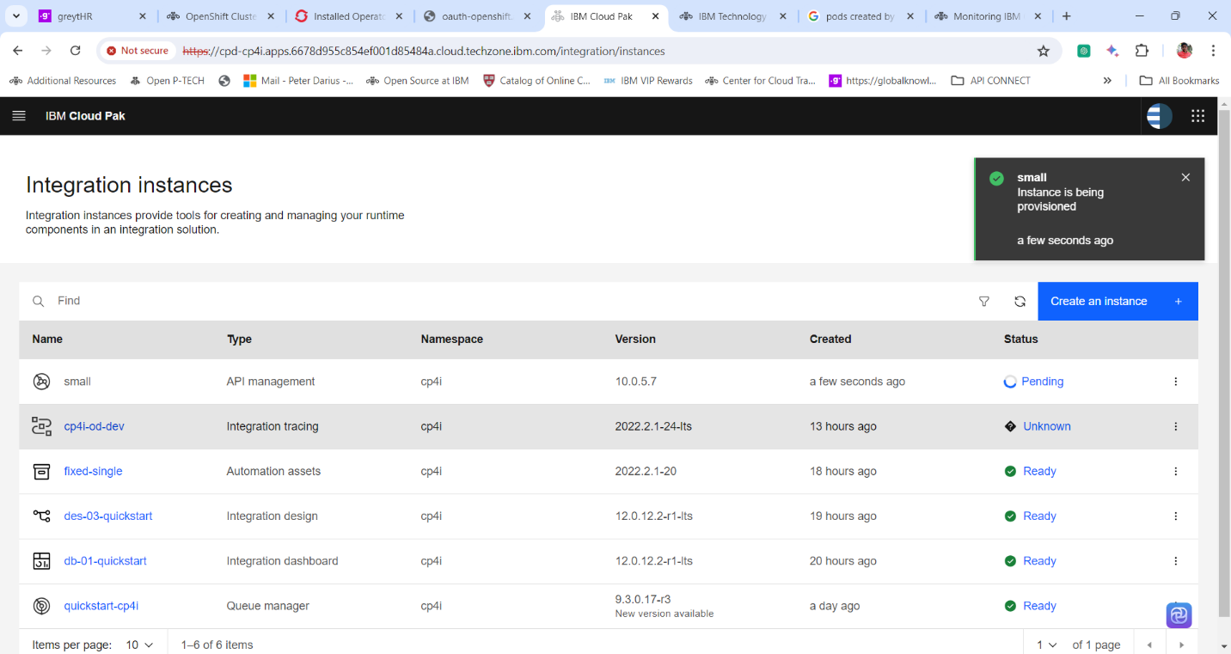

12. After the Instance has been created and the status is Ready click on the name **small** of type **API Management** to open API Connect console. It creates the following three instances:

**a. small-gw = API-managed enterprise gateway**

**b. small = Cloud Manager**

**c. small = API Management**

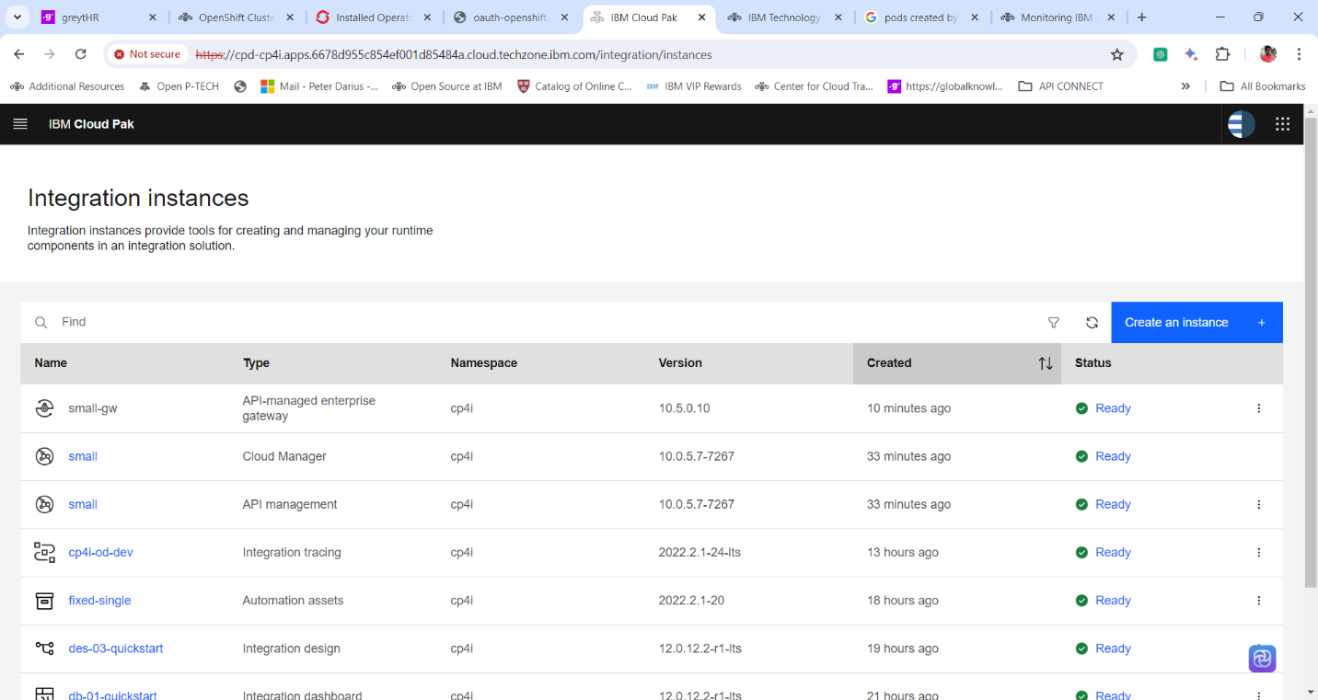

13. API Connect Console.

14. Let’s check the API Coonect pods created. Login into the Red Hat OpenShift Console. Expand **workloads** and click **pods**.

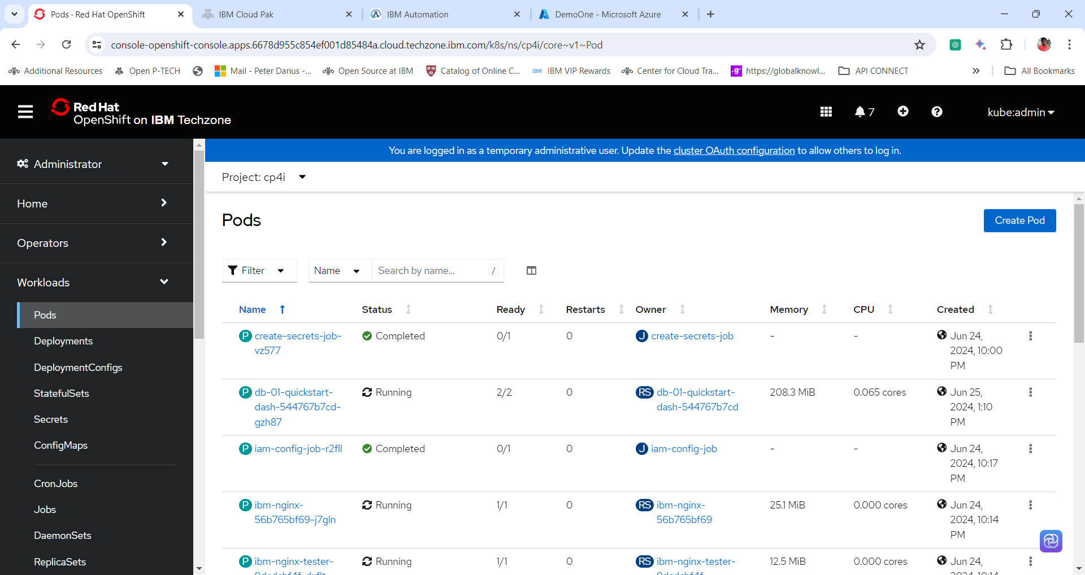

15. Change the **project Name to cp4i**. In the **search box** search integration dashboard pod by giving integration instance name i.e **small.**

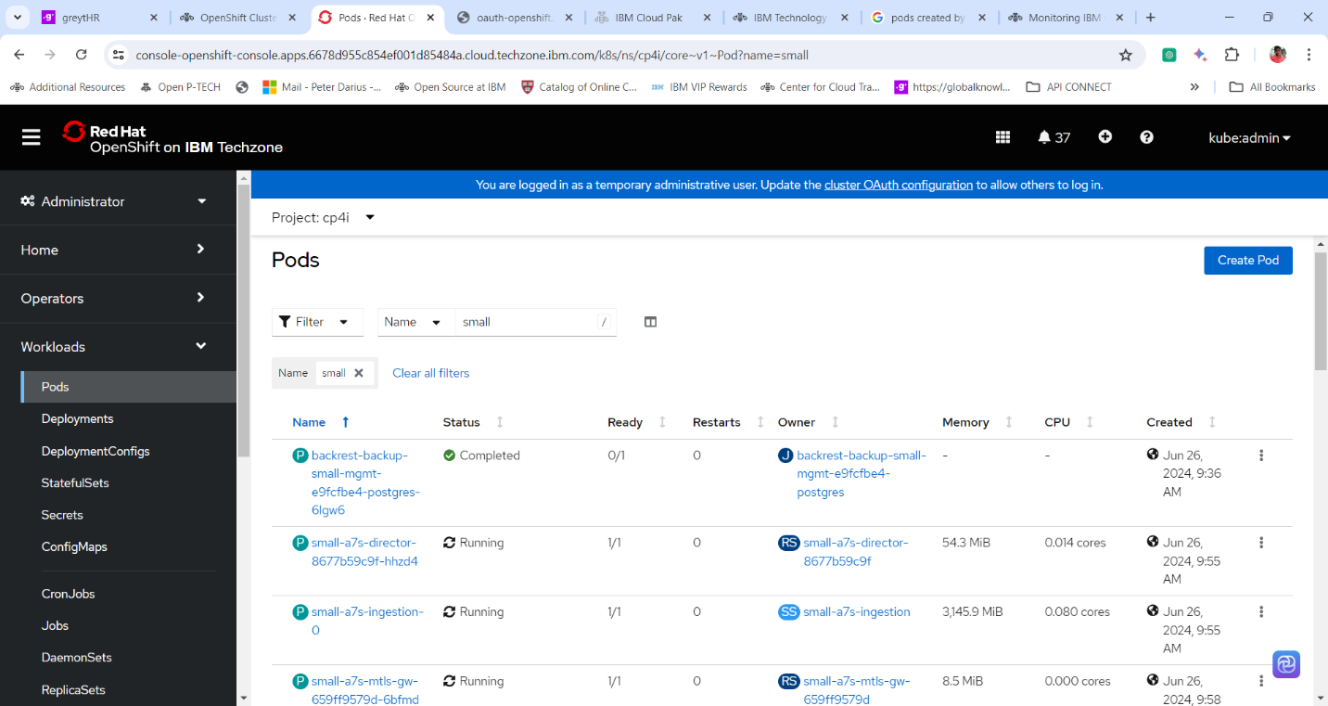

**Thanks for successfully completing the Lab.**